**RESUME AND COVER LETTER APPLYING FOR A JOB**

**SESI 2023/2024**

**DET4C**

**PREPARED FOR:**

**LECTURER: MADAM NUR HARTINI BINTI HARUN**

**PREPARED BY:**

|  |  |
| --- | --- |
| NAME: | NO MATRIX: |
| CHONG KHENG CHEN | 03DET22F1043 |

**CHONG KHENG CHEN**

TELEPHONE NO. (MOBILE):019-497-2588.

EMAIL ADDRESS: khengchen3113@gmail.com

**PERSONAL PARTICULARS**

DATE OF BIRTH:4 DECEMBER 2004 MARITAL STATUS: SINGLE

PLACE OF BIRTH: KEDAH, MALAYSIA NATIONAL: MALAYSIANS

**EDUCATION:**

August 2022 POLITEKNIK SULTAN ABDUL DIPLOMA IN ELETRIC

HALIM MU’ADZAM SHAH ENGINEERING OBTAINED

(POLIMAS) BANDAR DARULAMAN CGPA SCORE OF 3.65

06000 JITRA, KEDAH

2022 SEKOLAH MENENGAH KEBANGSAAN SPM WITH DISTINCTIONS IN

TUNKU ABD AZIZ SIMPANG EMPAT MATHEMATICS AND HISTORY

06650 ALOR SETAR, KEDAH

**WORK EXPRENCE**

1. COMPANY’NAME: FASTCON ENGINEERING SDN.BHD ALOR SETAR KEDAH

POSITION: SHOP ASSISTANT

DATE: JUN 2022-JULY 2022

JOB SPECIFICATION :1. PROCESSING DOCUMENTS IN WORD

2.PROCESSING COMPANY DATA BY USING EXCEL

3.CALCULATE QUOTATION

2. COMPANY’NAME: HOONG FOONG DIM SUM USJ 21 SUBANG JAYA SELANGOR

POSITION: WAITERS

DATE: JUNE 2023-JULY 2023

JOB SPECIFICATION :1. TAKING ORDER

2.INTRODUCING FOOD TO GUESTS

3.COLLECTING MONEY AT THE COUNTER

3. COMPANY’NAME: NERDUNIT POP UP AT ISETAN LOT 10

POSITION: PROMOTER

DATE: AUGUST2023-SEPTEMBER 2023

JOB SPECIFICATION :1. PROMOT THE SHIRT

HELP CUSTOMERS FIND SUITABLE CLOTHES

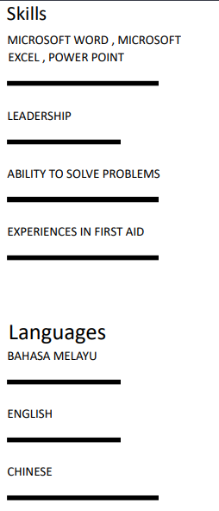

**EXTRA-CURRICULAR ACTIVITIES:**

JUN-DECEMBER 2021 LEADER OF ST JOHN AMBULANCE MALAYSIA

(SMK TUNKU ABD AZIZ)

* CADET LANCE CORPORAL
* FIRST AID MEMBER

**REFERENCES:**

The following persons have agreed to provide any additional information regarding my qualification and characteristics:

MADAM ERNIZA BT. ZAILAN MR CHONG KWO HONG

LECTURER Managing Director

POLITEKNIK SULTAN ABDUL HALIM FASTCON ENGINEERING SDN.BHD

MU'ADZAM SHAH (POLIMAS) BANDAR ALOR SETAR KEDAH

DARULAMAN 06000 JITRA, KEDAH

Telephone number: 019-559-5166 Telephone number: 019-448-2588